**EMPIRICAL EXERCISE 4**

GROUP 19: INDIA: Group Members: Taras Vorobets, Shail Shah, Parv Joshi

**Graphs for the United States**

1. **RGDP**

Starting from 1960-2017 we acquired data for the United States RGDP accounting for the 2015 Base year. Coming out of the span of World War II and entering into the ERA of the Cold War, the United States is seen to have a steady increase in the RGDP. As technological advancement thrived and people lived in peace, the economy thrived. We can see a steadier increase beginning in the 1990’s due to the developments of computers and automated industrialization which increased the capital and efficiency of every individual in the United States. Slowing down the 2008 market crash, the economy entered one of the biggest recessions on our data plot but quickly recovered and countied at an almost linear course, into current GDP levels. 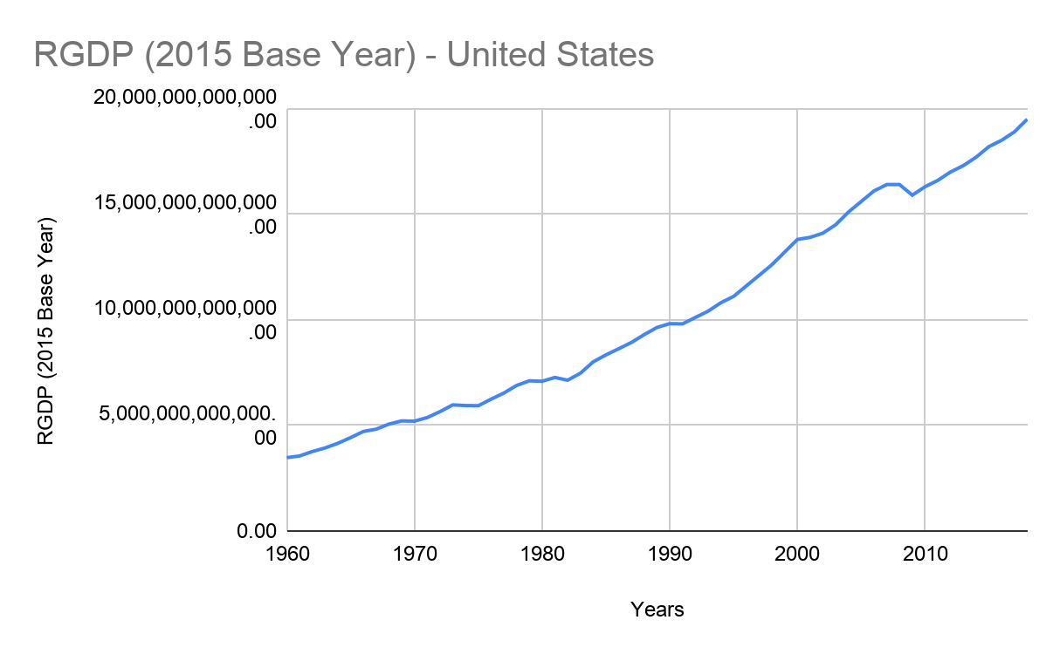

1. **RGDP per capita**

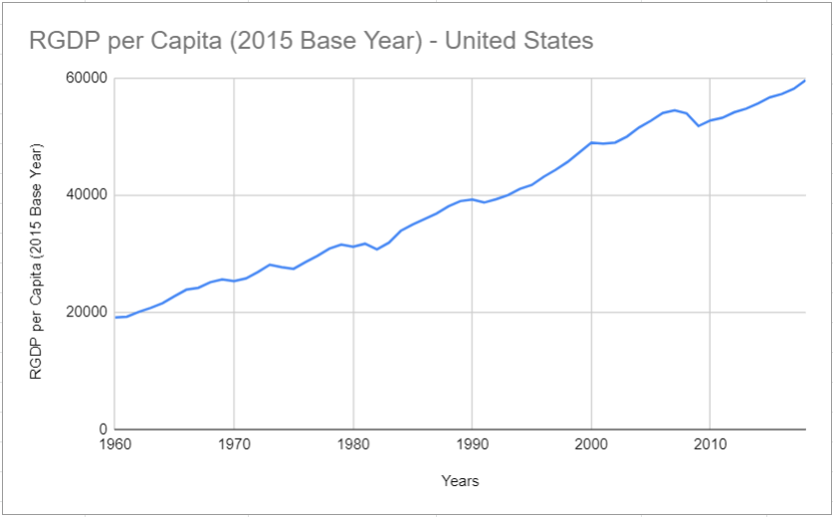

In terms of the RGDP per capita, we captured the time frame of 1960-2017 which exemplified the growth of individuals in the United States. Closely matching the trends of the RGDP, the RGDP per capita had a similar increasing trend, with similar economic slow downs as occurrences of recessions and economic difficulties that faced the nation at particular times. The biggest of which were the 2008 recessions, noticeable on the graph. Overall the trend countries in almost a linear fashion as the GDP per capita increased from around $20,000 in 1960 to approximately $60000 in 2017.

1. **Labor Productivity**

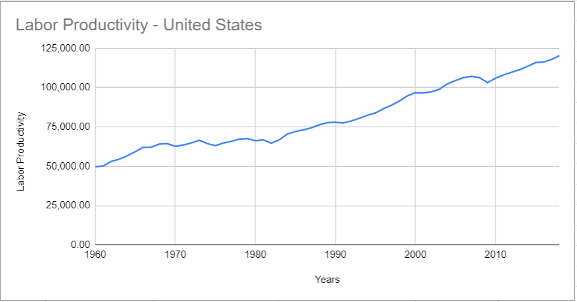

Our Labor Productivity data stems all the way into 1960, showing a steady increase in over the years. It’s clear that the labor productivity has increased dramatically due to technological growth making labor more efficient. The per worker output in 1960 was around $50,000 and in a span of less than 60 years, the labor productivity increased to $125,000 poratying the immense growth that the United States has gone through despite economic hardship.

1. **Labor productivity Growth rate and TFP growth rate**

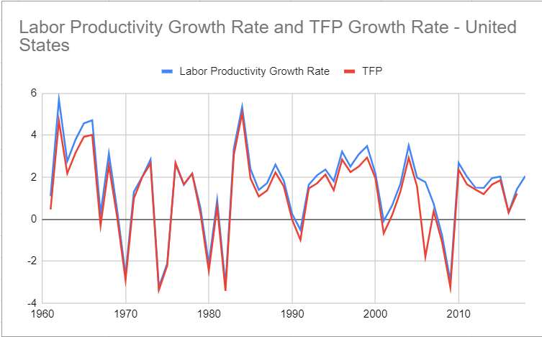

Labor productivity Growth rate and TFP growth rate over the years 1960- 2017 gave us a lot of information about the overall outlook on the development of the United States during economic peaks and troughs. Overall both the rates inhibit a similar rate due to various variables. Labor Productivity growth rate depends on the GDP and the labor force of a country. When a country experiences economic prosperity the labor force is productive and technological growth increases. However, during recessions and economic difficulties, such as the ones seen in 2008, we can see that the labor productivity growth rate decreased due to a lack of labor force as a result of large unemployment. We note that technological growth rate also decreases in recessions due to less investment in technological factors. In line with other variables besides unemployment, it’s clear that the Labor Productivity Growth Rate and TFP Growth rate follow similar patterns.

**Combined Results for the United States**

When looking at all the graphs in accordance, it was easy to see the relationship between all of them. For the United States we worked with a complete data set which ranged from 1960 to 2017. This gave us a complete understanding and outlook on how much the economic development in the U.S has matured. It was clear that the RGDP and RGDP per capita grew similarly due to a relatively similar rate of increase in income and population. RGDP and RGDP per capita links to the growth rate of the labor force as well the technological growth. Recession decreases the number of people in the labor force and hence their ability to innovate and cause technological growth. This in turn decreases RGDP and RGDP per capita. These statistics together drive the economy and complete the full picture of the economic standing of the United States on each given year. If you take a look at the graphs it's clear that the US has been developing in various ways. Stemming from labor productivity which has more than doubled, the RGDP per capita tripled, and RGDP more than quadrupled. These statistics create a clear understanding that the United States economy is steadily developing.

**Graphs for the India**

1. **RGDP**

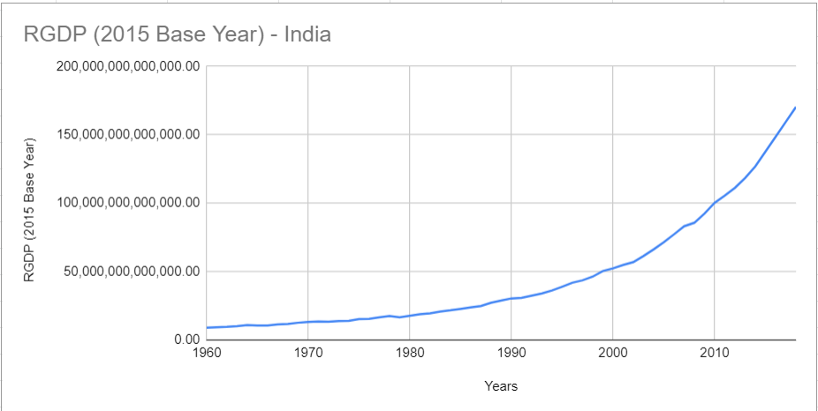

We acquired data for the RGDP of India from 1960 to 2017 in rupees. The rate at which India has grown over the last 60 years was the result of major economic reform that took place in the late 1990’s. This is visible as the nation’s RGDP has seemingly exponential growth starting from almost nothing to nearing 175 trillion rupees in 2017. This exponential growth is the result of major investment into technology as well as increases in labor productivity. WIth increasing per capita of real GDP of each individual, the nation was able to experience economic prosperity, which is not as affected by economic hardship, due to its exponential growth. It’s clear that in terms of the Solow model, India is beginning to approach its peak in terms of rate of growth, showing a promising and economically viable future.

1. **RGDP per Capita**

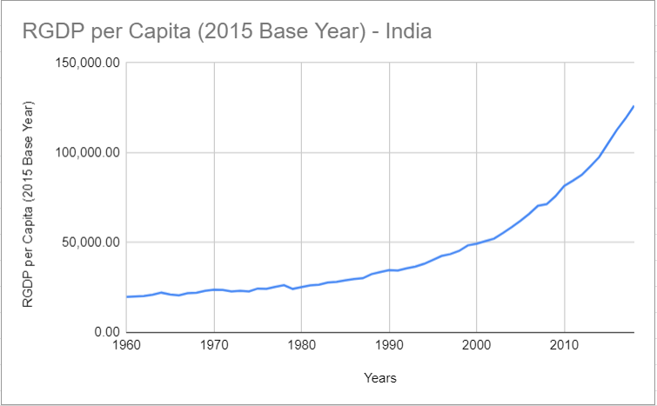

In line with the RGDP, the RGDP per capita shows a similar trend starting from the 1960’s into 2017. Calculated in rupees, the trend appears to be exponential as the due to the rapid growth rate of the country starting in the late 1990’s as a result of economic reform, the per capita real GDP for individuals increased from less than twenty five thousand to one hundred twenty five thousand. This major increase was a result of the labor force productivity in accordance with vast technological growth improving the efficiency of every individual, allowing the nation to prosper by increasing the per capita real GDP of their workers and utilizing the resources of the large population.

1. **Labor Productivity**

Due to limited data, we came into a problem observing the trend for labor productivity in India for a long term. Only having about thirty years of data to work with, it was still clear that India’s labor productivity is increasing exponentially at a rapid rate. Beginning in 1990, the labor productivity was about one hundred thousand rupees per worker. At the end of 2017 this statistic increased to around three-hundred-fifty thousand rupees. It was clear that this exponential growth was a result of the reform and economic adjustment that the country has gone through, and we predict that if we had data for all the years the growth would be even more significant. With enormous increase in population and hence the labor force, it is evident that the increase in labor productivity attributes to a even higher level of labor efficiency caused by a high technology growth rate and increase in human capital.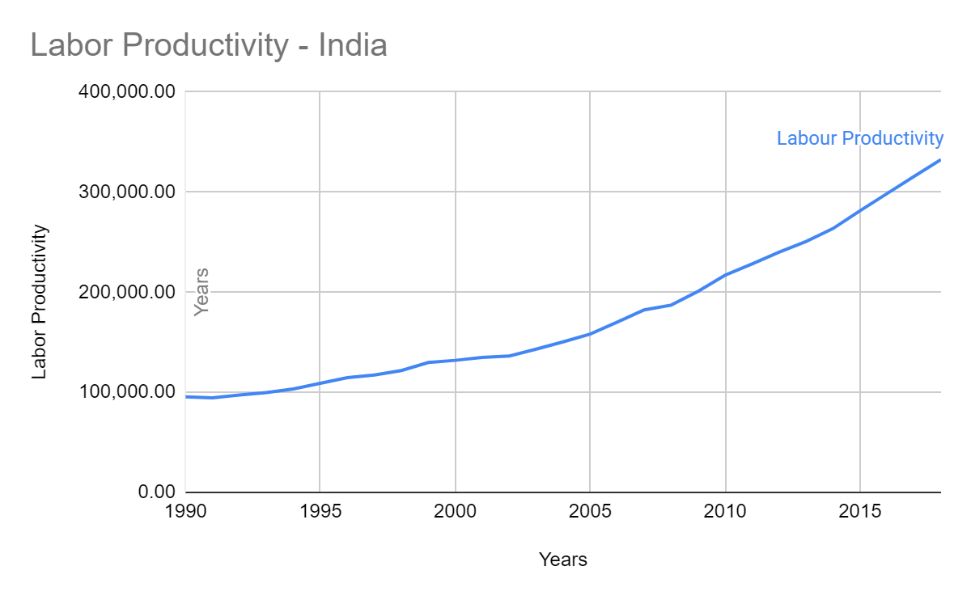

1. **Labor productivity Growth rate and TFP growth rate**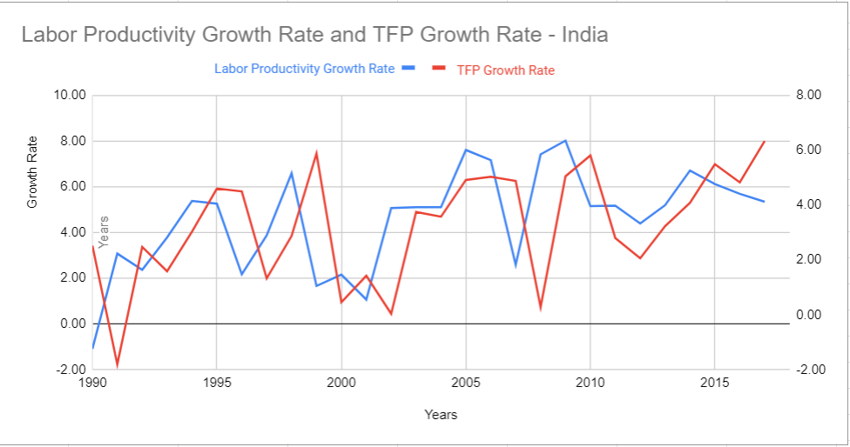

Once again, the data for the labor productivity growth rate was limited, resulting in limited data for the TFP growth rate. Despite this shortcoming, we were able to produce a rather informative graph that still exemplified the growth rates of India. Beginning in 1990, at the peak of economic reform the labor productivity rate began increasing as more people began to take part in the labor force. Due to limited technology, the growth rate decreased for a short period of time, however rekindled and began to follow similar trends by 1993. The trends continued in accordance to the economic cycles, hitting peaks and troughs simultaneously. Despite having limited data, it’s still visible that both the TFP growth rate and the Labor Productivity are increasing in a positive direction, portraying the future growth of India.

**Combined Results for the India**

Looking at all the graphs for India, it’s clear that the country is rapidly developing its evolving economy. When looking at the graphs for the RGDP and RGDP per capita, it's evident that the country has gone through major reform which has resulted in an economic boom. Starting from the 1990’s the exponential growth is present in labor productivity, which would ultimately be the result of major infrastructure, more competition among the huge population, and technological growth that increases the efficiency of workers. This then translated into growth for the RGDP per capita, which also experiences exponential growth throughout the same time frame. Overall this can be reflected in the RGDP which takes into account all factors and has nearly a twenty fold increase in rupees of around ten trillion to nearly two hundred trillion. This staggering growth is the result of technological growth in account with labor productivity growth as well as other variables present in India. By looking at the data, an indication of future economic prosperity is definite for a developing country line India.

**Table 1: Growth Accounting Exercise for the United States: 1960-2017 (Entire Time Period)**

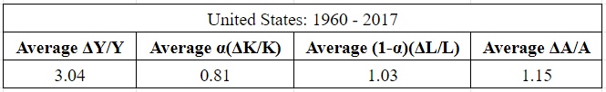

These are the total averages stemming from the years 1960-2017 (The entire time period for which we have data). They represent the average annual ratios of(ΔY/Y), α(ΔK/K), (α-1)(ΔL/L), and (ΔA/A). The total output of the United States should be the cumulative sum between the three averages. These years include the developing economic statistics which occurred through the Early 80’s Recession, Black Monday, the 2001 dot com bubble, and the most recent 2008 financial crisis. They represent that the overall average of the labor compared to capital was higher through these years when you account for all the economic growths and crashes. The average output reflects that the technological growth through the history of the United States starting from 1960 to 2017 is relatively the same as the average of labor output. Together these figures make up the different sources of growth for the United States economy through 1960-2017.

**Table 2: Growth Accounting Exercise for India: 1990-2017 (Entire Time Period)**

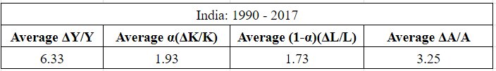

These are the total averages stemming from the years 1990-2017 They represent the average annual ratios of (ΔY/Y), α(ΔK/K), (α-1)(ΔL/L), and (ΔA/A). Working with limited data for India, the data is curved toward more recent growth of the economy, showing a large output. During this time period, many economic developments took place. India's economy started growing exponentially increasing after staggering technological growth occurring at the start of the 20th century. Trying to optimize labor, the nation's development of capital was a large portion of its total output. We also see that the GDP share of capital is more than the share of Labor despite its enormous population. From the data, it is clear that this could be because of its increase in the unemployment rate which peaked in 1993, 2002 and 2009. However, the major impact of the high average output India has managed to produce during these years came from large leaps in technological advancement, which from 1990 to 2017 consisted of almost half of total output.

**Overall Comparison**

Looking over all the data we’ve acquired for both India and the United States we made numerous comparisons between the two. Despite the countries experiencing relatively similar economic crashes during the same periods, the statistics remained relatively similar from different sub-periods for each country. The United States experiences relatively similar capital and labor outputs. India experienced increased growth after the reform of 1991 which converted the government to be more focused on economic growth and trade. In both countries, the share of capital and labor was almost the same as total output. However, in the U.S the share of labor was slightly higher than the capital while in India the share of capital was slightly higher than the labor. Technological growth was quite a surprising statistic for both countries as it made up about half of the total output for both India and the United States, demonstrating its importance in Economic Development. Growth rates in India were much higher due to it’s rapidly expanding economy which was also visible through the higher outputs during the time periods.

When comparing India and the United States in terms of RGDP, RGDP per capita, Labor Productivity, Labor Productivity and TFP Growth rate, much of similar trends still stand. Both countries experience similar patterns in terms of economic down turns and economic booms. Unlike the United States which has remained relatively steady in terms of growth however, India has seen an exponential growth on all accounts as a result of its 1990 economic reform. It is clear that India is far from its Steady State, and is approaching its peak for growth. The United States, however, is approaching its steady state and has steady growth for a while. Given the major technological advancement as well as the increased utility and efficiency of a large population at hand, India has a definite prosperous economic future. The United States, just like India shares a similar economic development pattern, despite being over its peak in terms of growth according to our Solow model, the country is limitless in its ability to expand through technological growth and various other factors.

Overall, despite the data constraints for India, both countries showed remarkable economic growth consisting of different economic factors and shocks (positive or negative), which as a group we found very interesting to observe and analyze.

**World Bank’s Doing Business 2020**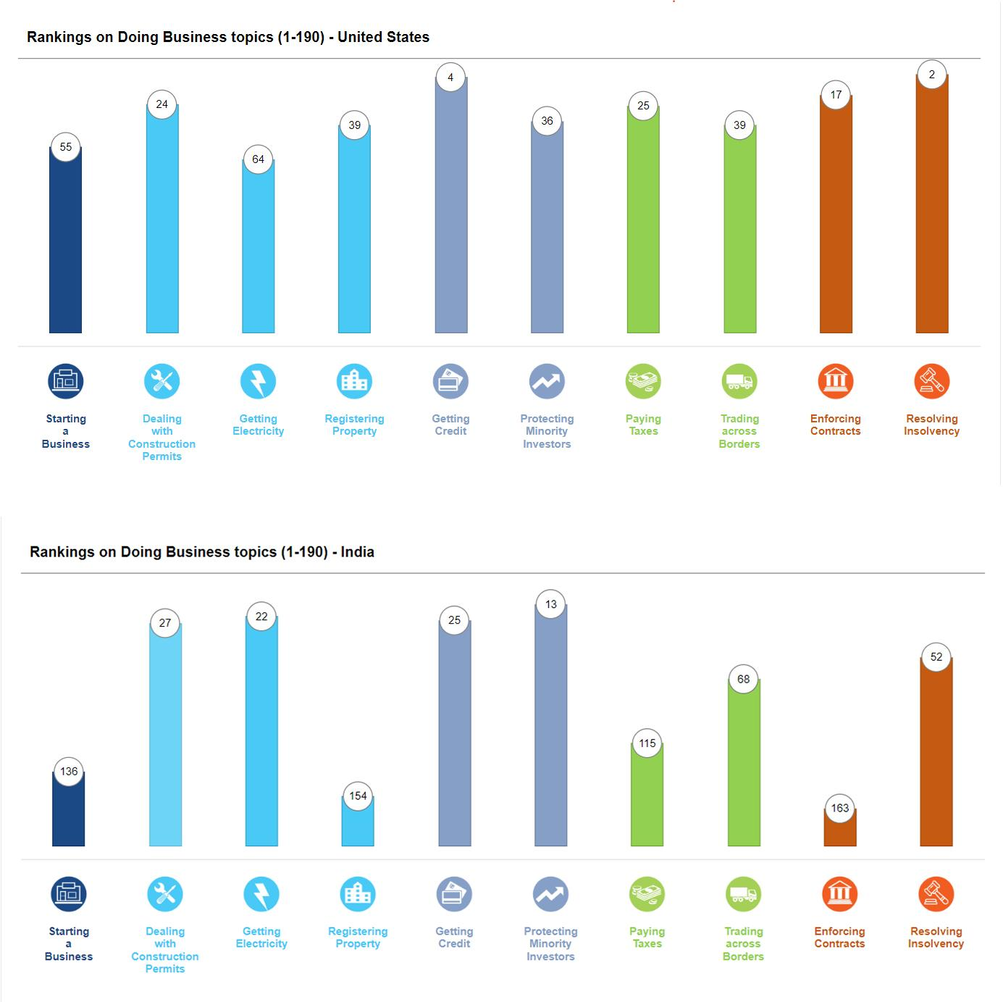

After visiting the World Bank’s Doing Business 2020 report for both the United States and India. We observed all the given data structures provided. The results surprised us, as we expected, the data sets to be vastly different.

In the United States the business categories that stood out as doing relatively well compared to other countries were resolving insolvency, getting credit, enforcing contracts. These three go hand in hard, standing as the core foundations of the United States economic and financial center. The ability to get credit, enforce contracts, and solve insolvency allows for the successful financial flow of currency and debt. In terms of the countries shortcomings, the United States is doing relatively well is acquiring electricity, starting electricity, registering property. Despite not seemingly having low rankings in these respective things it’s quite simple to understand why these three would be related. Despite being known for its cities, a majority of the United States is rural area and registering property, acquiring electricity as well as even starting a business in these areas is extremely difficult. Overall United States does relatively well in an average score, ranking #6 on the total scale.

In India, the business categories that stood out as doing relatively well compared to other countries were protecting minority investors, getting electricity, and getting credit. These three, despite being in different categories relate to one another in various ways. India being a developing economy means that a lot of infrastructure needs to be created in order to sustain its economic growth. Local and minority investors need to be protected and supplied with credit in order to create these infrastructures, by protecting and evolving these business categories, India is able to economically develop at the rapid rate we see in our statistical data. In regards to the country's shortcomings, India is not doing relatively well in enforcing contracts, registering property, and starting business. Despite being successful at developing infrastructure, sustaining infrastructure is a vastly different business field. Due to India's large population the government is still efficient in controlling all aspects of lawful institutions which would help with enforcing contracts, registering property, and creating business. Overall, India still comes in a high rank among other countries, placing at #63 on the total scale.

**Recommendations of Policies for Each Country**

**United States:** The United States is a developed nation and has reached its steady state level and although it may be considered a developed nation there are quite a few things that can be implemented to improve the standard of living. Firstly, they need to work towards taxing the corporations in a better way by increasing taxation on investments. This would improve tax revenues and bring about equality in society. They also need to change laws that allow some of the big companies to not pay taxes and although the government might be aware of it, politics and lobbying preside over and the wealthy are not taxed enough. Secondly the United States needs to work on improving its healthcare system. Stricter policies governing the private insurance companies should be enforced so that people do not end up paying high costs for health care. The United States also seems to be on the backfoot of global warming and climate change. With fewer policies governing major companies and industries, it is important the US take steps to reduce carbon dioxide emissions. Maybe policies like paying a tax on carbon dioxide emissions and improving systems that reduce emissions would increase the standard of living in the long run. Another issue the United States should address is higher education. With students fearing the high costs of higher education and the education system turning it into a business. Policies need to be put in place to encourage students to attend school. This would help increase the standard of living overall.

**India:** India is a rapidly growing country and its economy is still to reach its stable state. In order to increase its standard of living India needs to act on key areas and certain industries that largely affect its economy. The first market we think it needs to venture into is the Agriculture industry. India is an Agro-based economy. With continuous droughts across the country, loss of crops, and farmers committing suicide the industry does need to receive a large amount of stimulus. They need to make technological advances and make them available to farmers everywhere. Although the technologies exist they need to be implemented on a larger scale. This needs to be coupled with more sophisticated farming techniques that will allow them to move to high-value activities. They should also provide low-interest loans to farmers to invest in new technologies and establish programs that allow farmers to get educated in newer practices. Another issue India faces is its unemployment. They need to create jobs by allowing companies to set up base in India or move their base to India by giving the company certain incentives. This would help create jobs. Another issue India faces is that a majority of the workers are stuck in low income and low productivity jobs. This can be mitigated by creating new jobs and allowing the ease of business. Simultaneously India needs to work on improving its quality of education. With very few good secondary institutions and the lack of good quality teachers and rampant corruption in the education business, India is really lacking here. They need to implement government policies that will allow for children and adults in the villages and smaller cities to be educated. These things overall would allow people to get better jobs and increase the standard of living. Next, India needs to focus on digitization. With the country still struggling to have 24/7 water and electricity in certain regions, digitalization may seem to be a far stretch but it is not impossible. They need to make efforts to provide broadband and wireless services to even the most remote regions and villages. This will allow for better educational and work practices and in many ways allow for training and hence improve the standard of living in the long run.